AI ASSISTED CODING
ASSINGMENT-9
NAME:K.POORNACHANDER
HALL.NUMBER:2403A52382
BATCH:AI 14
Task Description#1 Basic Docstring Generation
- Write python function to return sum of even and odd numbers in the given list.
- Incorporate manual docstring in code with Google Style
- Use an AI-assisted tool (e.g., Gemini, Copilot, Cursor AI) to generate a docstring describing the function.
Compare the AI-generated docstring with your manually written one.
GEMINI:
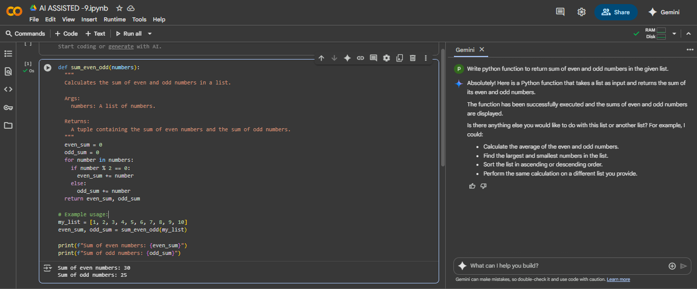
EXPLAINATION:
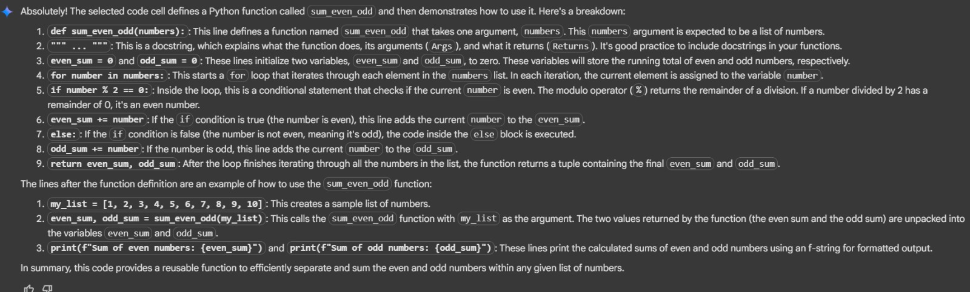
COPILOT:
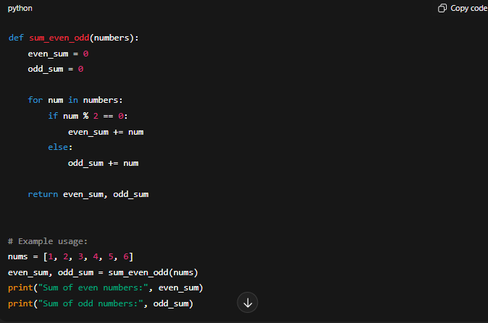
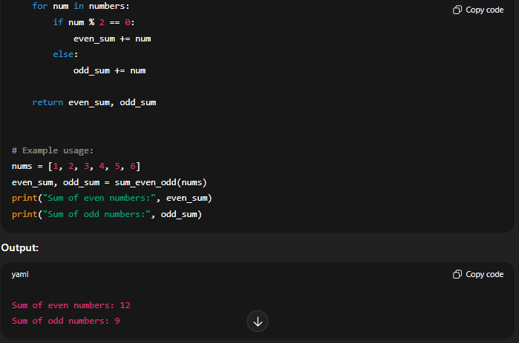
EXPLANITION:
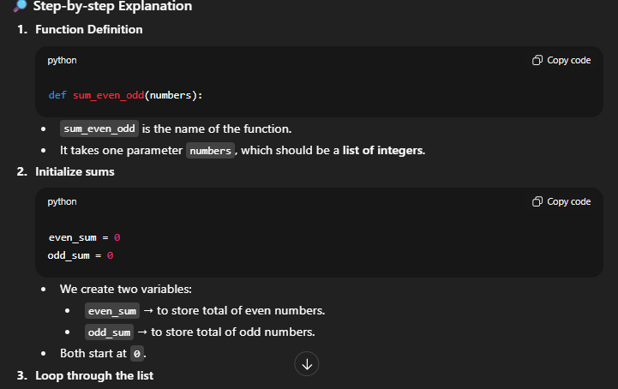
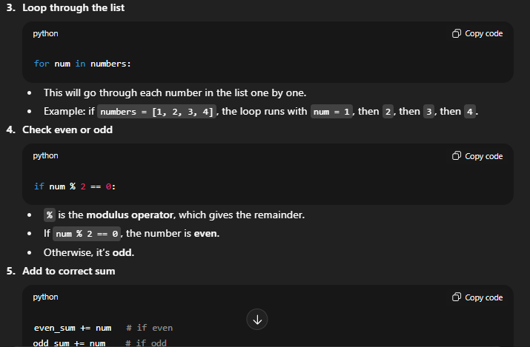
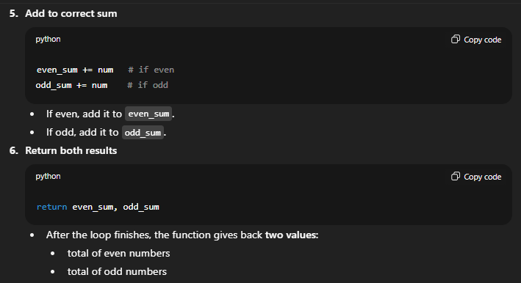

Task Description#2 Automatic Inline Comments
- Write python program for sru_student class with attributes like name, roll no., hostel_status and fee_update method and display_details method.
- Write comments manually for each line/code block
- Ask an AI tool to add inline comments explaining each line/step.
- Compare the AI-generated comments with your manually written one.
GEMINI:
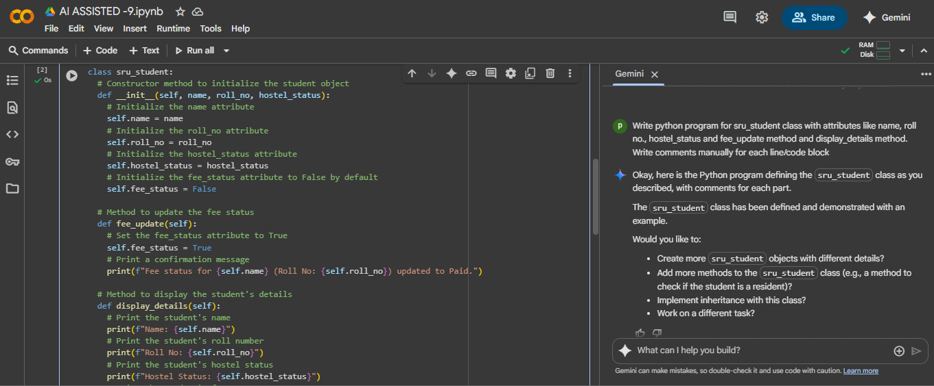

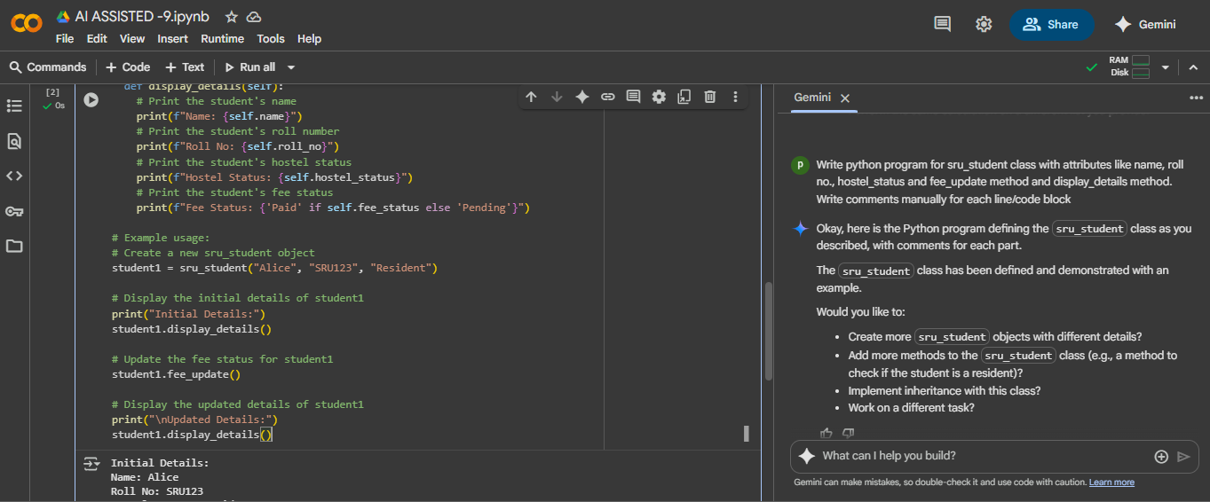
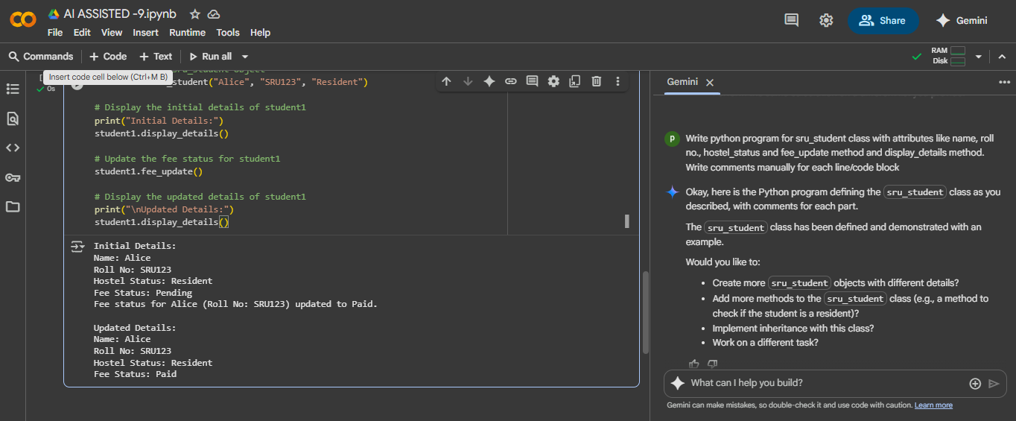
EXPLAINATION:

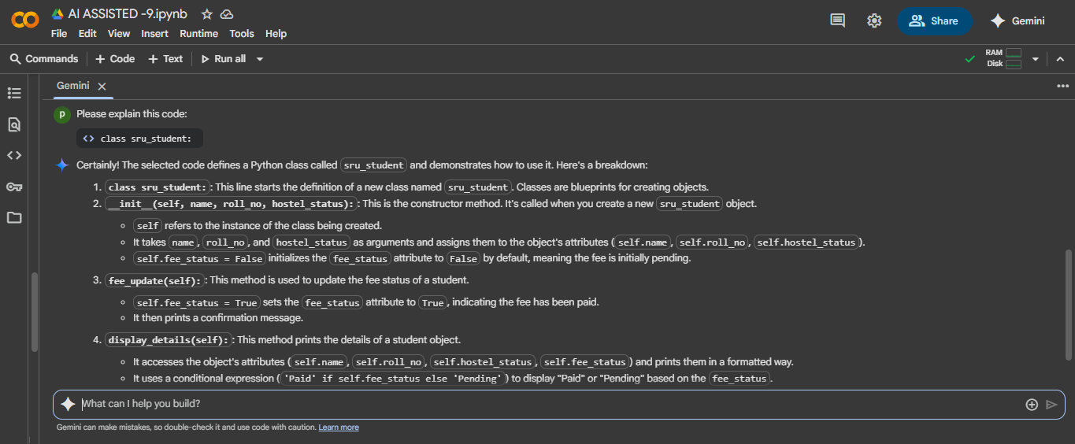
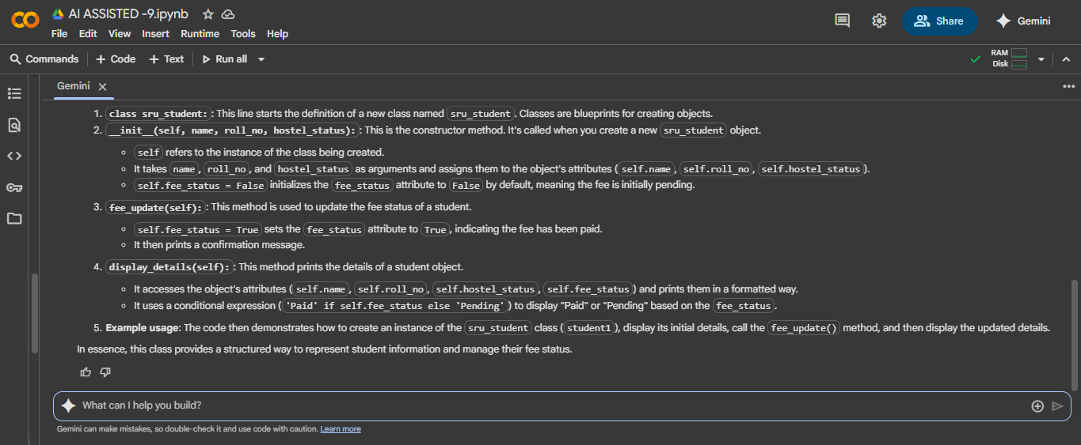
COPILOT:
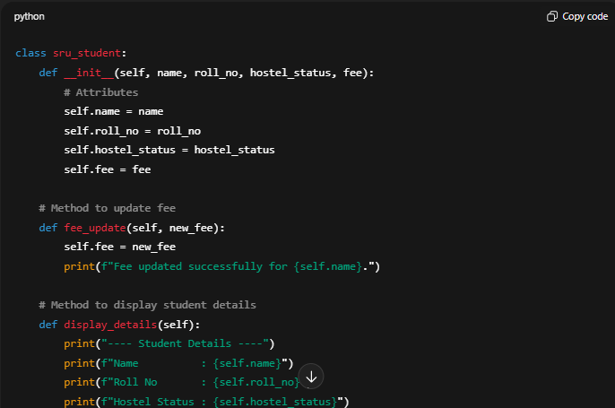
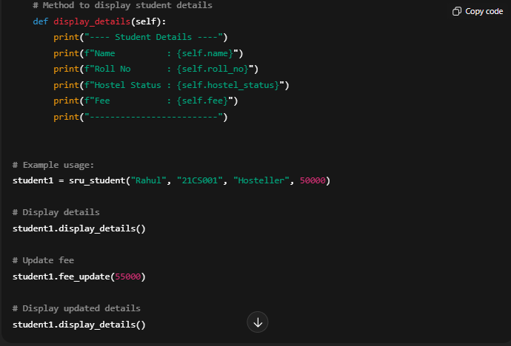
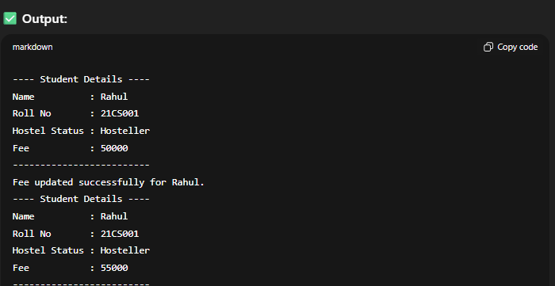
EXPLANATION:
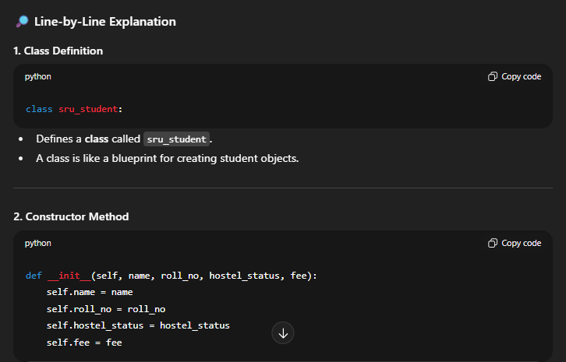
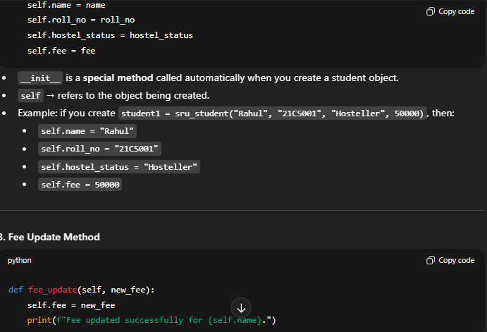
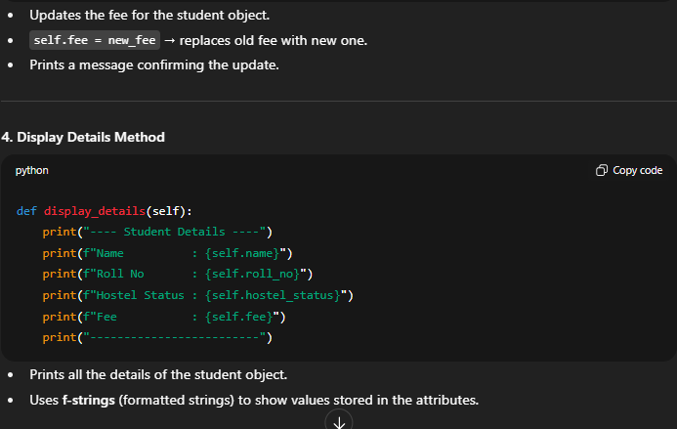
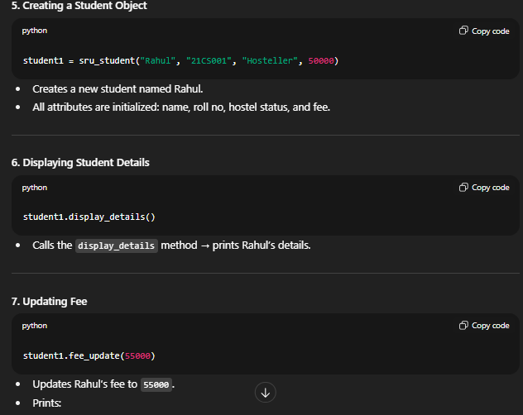
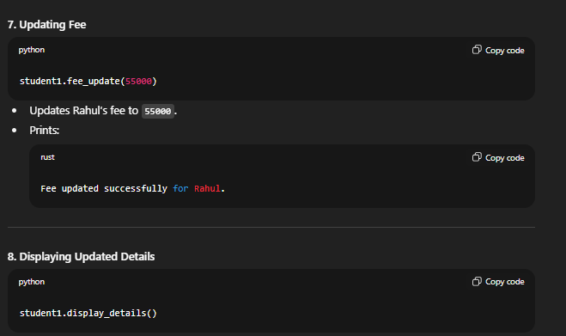

Task Description#3
- Write a Python script with 3–4 functions (e.g., calculator: add, subtract, multiply, divide).
- Incorporate manual docstring in code with NumPy Style
- Use AI assistance to generate a module-level docstring + individual function docstrings.
- Compare the AI-generated docstring with your manually written one.
GEMINI:
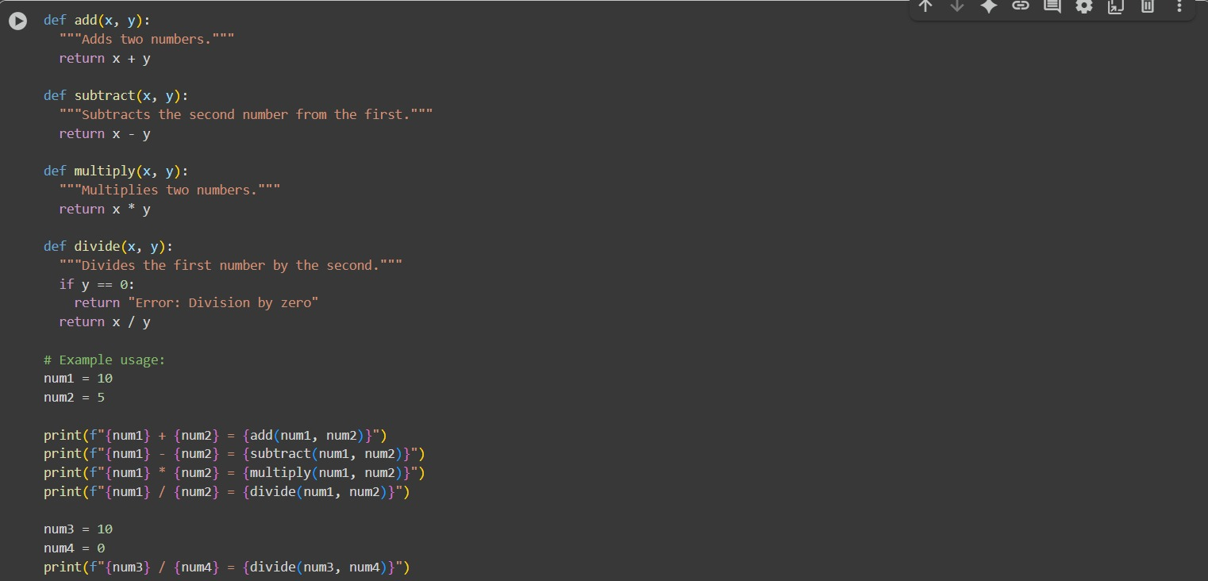

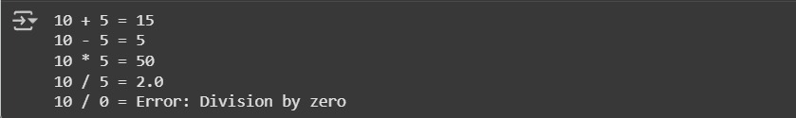
EXPALINATION:

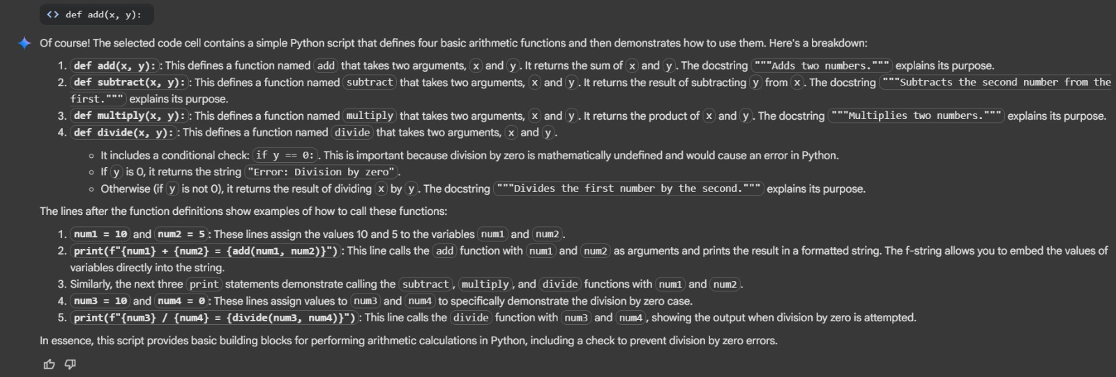
COPILOT:
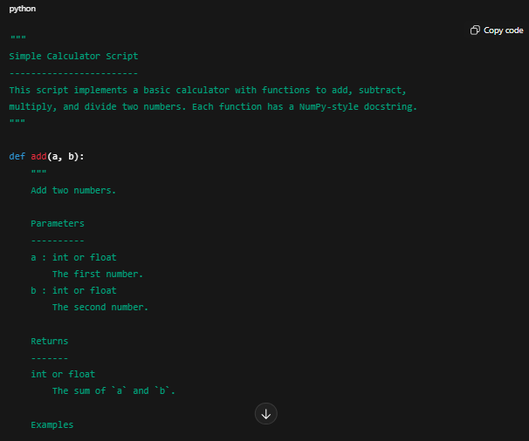
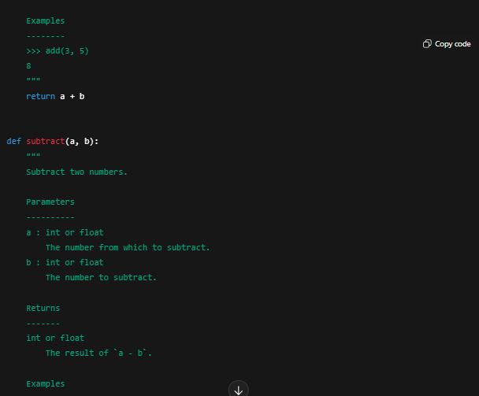
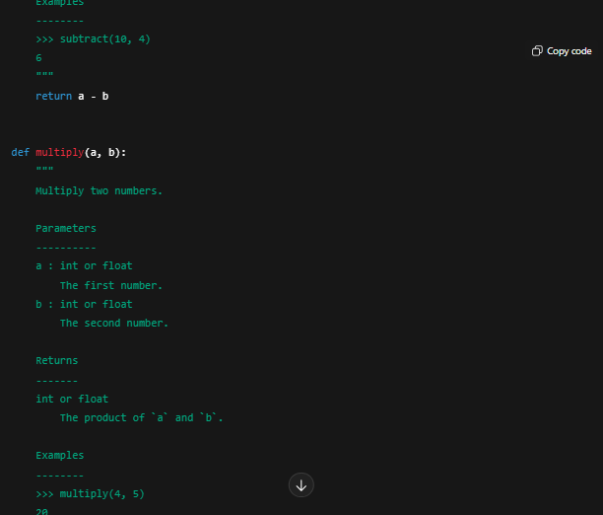
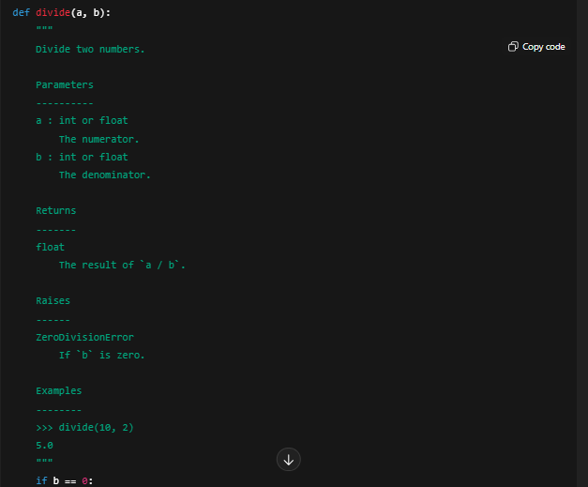
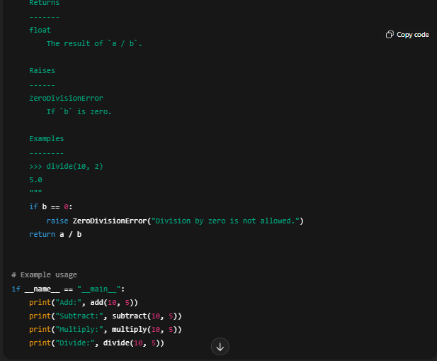
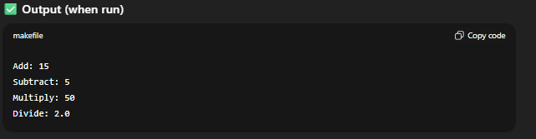
EXPLAINATION:
